SMS Data Editor Manual

# Getting Started

1. SVN Checkout -> SMS/SMS General/SMS Data Editor to keep updated.
2. Create a desktop shortcut to SMS General/SMS Data Editor/SVNUpdateThenRun.bat. Go into the properties of this shortcut and change its icon to be the same as SMSDataEditor.exe
3. Change the paths in SVNUpdateThenRun.bat and SVNAutoCommitIni.bat to reflect your local SMS Data Editor directory.
4. The program is password protected. Password = ‘dev’. Otherwise, use the shortcut parameter “SMSDataEditor.exe“ -dev for the target to skip the password.

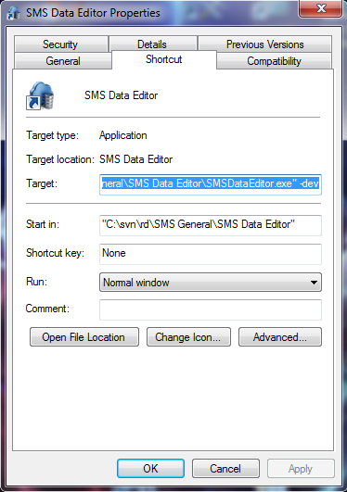

1. Set your schema directory in Settings. E.g. …SMS\trunk\DataModel\Schema

# Selecting a database

To choose a database, press ‘Database’. This will show a tree structure similar to other data editors, but simpler. Servers->Alias->Tables. This should be adequate for now as SMS doesn’t use generators, views, stored procedures, etc. It can connect locally to any Paradox or Nexus database and remotely to any Nexus database on the network. Clicking the Close button makes the tree view invisible again.

If an alias is highlighted bold it indicates you are connected to that database.

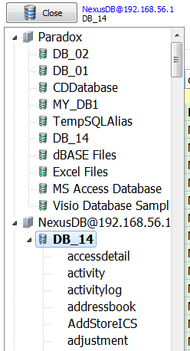

If you double click an alias it will close all open tables, disconnect and then connect to the selected alias. If you double click a table it will do the same then open the table in the first tab.

If you right click a server, a pop up menu with ‘Create Alias…’ will appear. Left clicking this menu option will show this screen, where you can create an alias on the selected server.

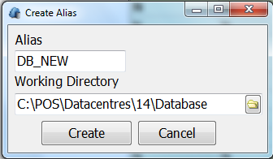

If you right click an alias, you get this popup menu.

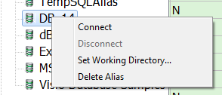

You cannot disconnect from an alias you’re not connected to. This makes sense. If you right click the alias you’re connected to, you cannot connect, set working directory or delete the alias.

Choosing Set Working Directory.. shows the same Create Alias as above but the alias name is disabled/greyed out.

Right clicking a table enables you to view the table’s schema comment, without needing to open it.

# Basic Navigation

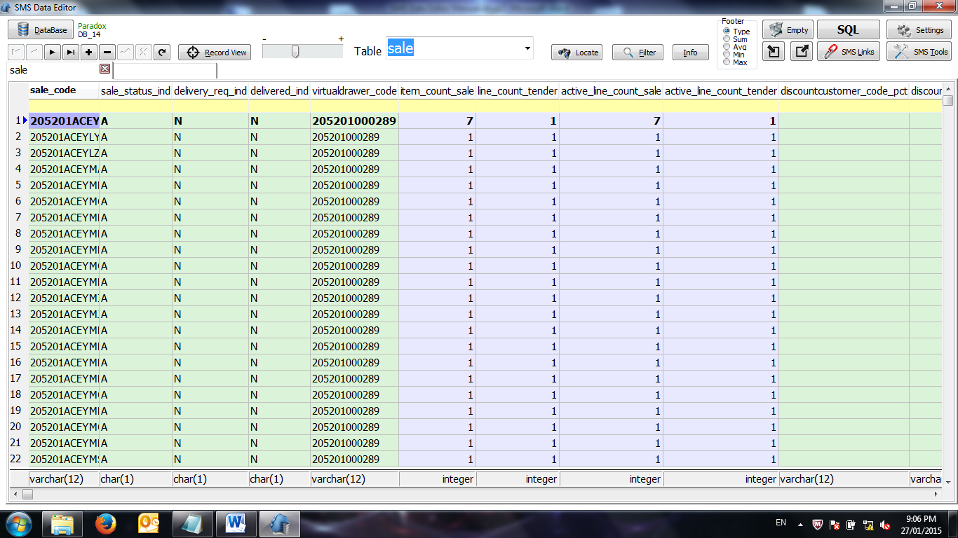

**Opening Tables**

To open a table, type the table name into the edit box and press enter, this puts the focus in the grid. It uses autocomplete and has a dropdown.

To open another table, click on the next empty tab, this brings the focus straight to the table edit box. Alternatively, press Ctrl/Alt + O.

The data can be directly edited in the grid. After editing a cell, move to another row or press the tick button to post.

The field that is highlighted bold indicates that it’s the primary key. In our case, this is usually the first column in the table.

**Navigator**

- The navigator on the top left allows you to move up and down through the records. Alternatively, use the mouse wheel.

- The + and – buttons allow you to add or delete a record

-The tick button allows you to post a record if in edit mode and the cross cancels any changes made to the record before posting. Alternatively, Ctrl + Z will also undo any changes you’ve made to a cell.

-The button to the right of the cross reloads the query/table in view.

**Record View**

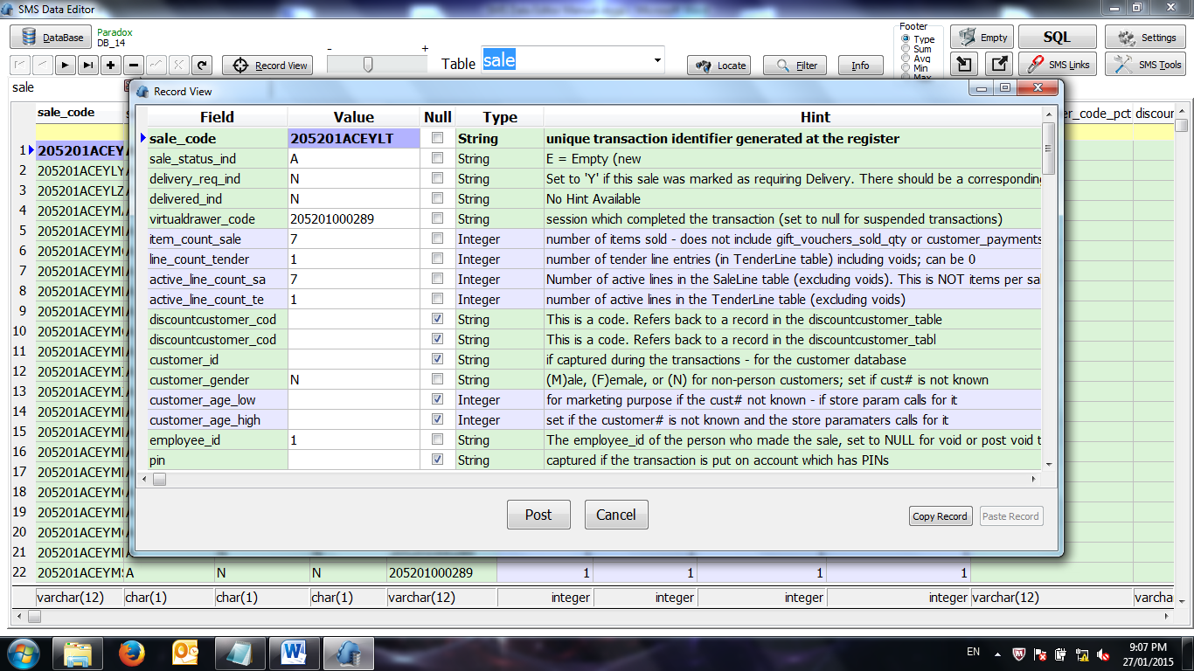

The record view button allows you to focus on the currently selected record. You can make changes to the value column, then post or cancel any changes made.

You can copy an entire record by pressing ‘Copy Record’. It’s stored globally, so you can even paste it into a different database. The ‘Paste Record’ is only enabled if the fieldnames match and a record has been copied. It’s your responsibility to change the primary key if necessary.

**Zoom Track Bar**

Dragging this bar increases/decreases the font size in the grid and is remembered using a registry setting.

**Table Info**

This shows the table’s comment as well as any indices on the table. This information comes from the DataGenie schema .ddl files.

**Footer**

By default, the footer of the grid will show the data type of the column, this information comes from the DataGenie schema .ddl files. Switching to sum/average/min/max will calculate these statistics on all columns in the active tab.

**Moving Columns**

The columns are not fixed. Simply drag and drop the column heading to move it.

**Tips**

-Scroll the mouse to move up and down by x records, this is configurable in Settings. Press the middle mouse button to toggle between scrolling up/down and left/right.

-Pressing Esc on any of the child screens in this program, cancels the operation and exits the screen.

# Locating/Filtering

The easiest way to search for records is to simply type into the first row in the grid, the filter row. It searches for records that contain the letters/numbers you’ve typed and filters as you type. You can filter on multiple fields at the same time.

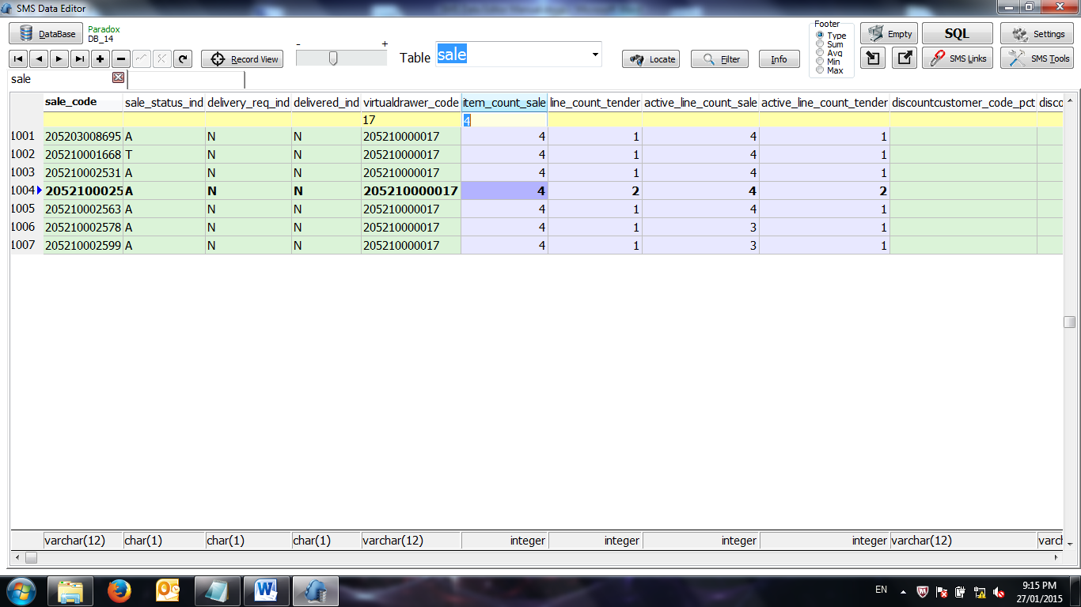

Locate uses the currently selected field, so click into a column first before pressing Locate.

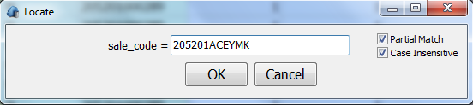

For a more complicated filter you may need to use the filter dialog.

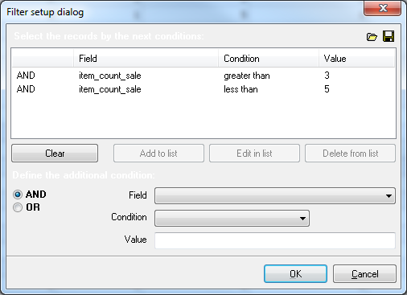

# Column Sorting/Setting value/Hint/Column Visibility

Left click on a column heading and it will show this pop up menu.

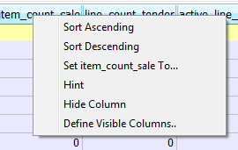

-Sort by ascending/descending. You can only sort on one field at a time.

-Pressing ‘Set (fieldname) To…’ then shows an edit box. If you press esc or click somewhere else, the edit box will disappear. In this example, pressing the enter key while in this edit box will set every value in the ‘item_count_sale’ column to be 2.

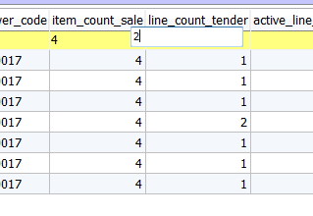

-Pressing ‘Hint’ will show the column’s comment from the DataGenie schema .ddl files.

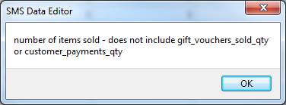

-Pressing ‘Define Visible Columns..’ shows this dialog. This adds settings to your Personal.ini file such that columns become permanently invisible when opening a particular table. Likewise, ‘Hide Column’ also permanently makes the column invisible, until you make it visible again.

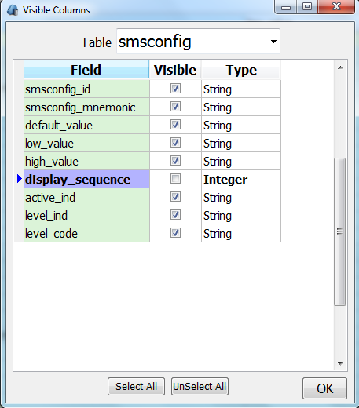

# Import/Export/Empty Table

Pressing the export button  will show this screen. By default, all fields will be selected but you can choose which ones to export. The delimiter only applies to exporting as a csv file, which you can open in Excel. After pressing Export, a filename chooser will appear to save the file.

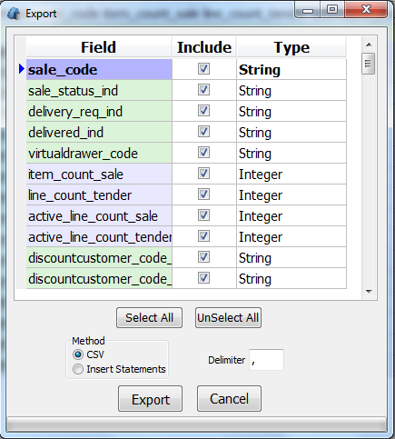

-Import by pressing  Importing only works with a .csv file and uses the same format as exporting. It will append records to the table. First it will check if the columns match, if not, it shows a message ‘Fields mismatch’. If an error occurs on a row, it will roll back the rows already imported, because importing is done using a database transaction.

# SQL

To execute SQL, simply type it in and press Execute. You can enter multiple SQL statements by separating them with ; It will execute each of these statements in turn.

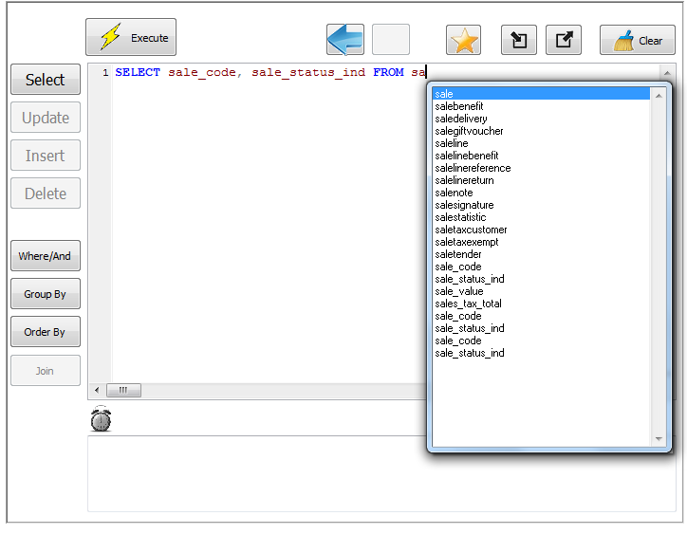

You can enter SQL parameters e.g. ‘select * from sale where sale_code = :sale_code’. In this case, a dialog will show for each SQL statement that has parameters. If you enter the same parameter across multiple statements it will remember the values you entered previously in subsequent statements, but you can still change them for each statement.

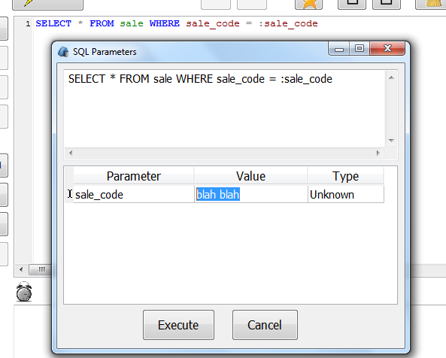

For each SELECT statement you have, it will put the output into the next available tab. The info button will then show the SQL used rather than the table schema comment.

Next to the clock image will show the milliseconds taken to execute all statements. It doesn’t include the time you spend entering parameters.

Below the clock shows a feedback message after you execute the sql. If the message is red, an error has occurred.

After you execute SQL, whether an error occurs or not, these buttons  allow you to go back to previously executed SQL.

If you have transactional statements (UPDATE, INSERT or DELETE), these buttons will appear which either commit or rollback the transaction.



If you enter ddl statements (CREATE/DROP/ALTER TABLE/INDEX), it will not use a transaction.

Note: You cannot to execute both transactional and ddl statements at the same time. You’ll get this message 'You cannot execute ddl statements with SQL that requires a transaction.'

Pressing the button  will show the SMS SQL Favourites screen. These SQL snippets are stored in the SMSDataEditor.ini file. You can add SQL to this file yourself and commit it to SVN. This is way for us to permanently share SQL. Try to make it general by using SQL parameters.

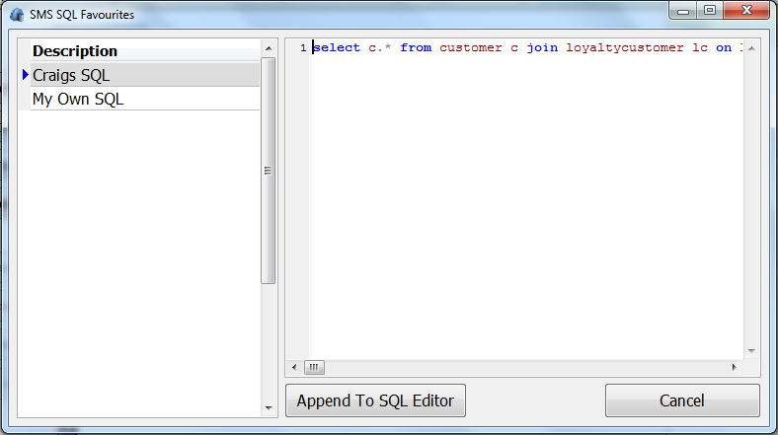

# 

# 

# SMS Links

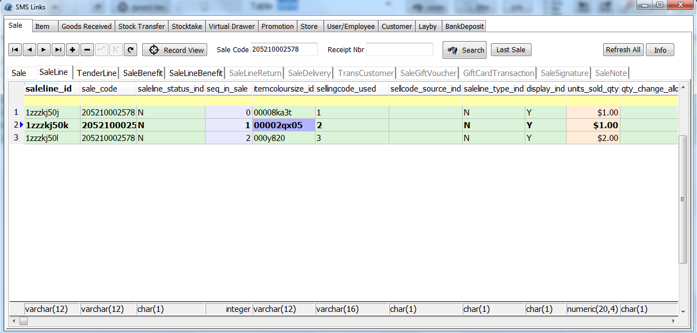

Many of the tables in SMS are related through master codes; sale_code, employee_id, store_code, etc. This sub screen attempts to link them together which is particular useful for support calls where you don’t always know what the problem is initially and need to see the data in a set of tables for a particular sale, grn, stocktake, etc. By entering a master code and pressing ‘Search’, it will open up a range of tables with only the records related to that master code and yes, the data is still editable. Internally, it uses select statements or subqueries. When the table heading is greyed out, it indicates that no records were found related to the master code you searched on.

-Pressing ‘Link From…’ will search through all the open tables in this screen looking for a particular code. In this case, it found ‘itemcoloursize_id’ in the saleline table, which was open at the time. It copied the itemcoloursize_id from the currently selected record in the saleline table, pasted it into the edit box and pressed ‘Search’. This operation is basically a fast way of doing copy/paste then search.

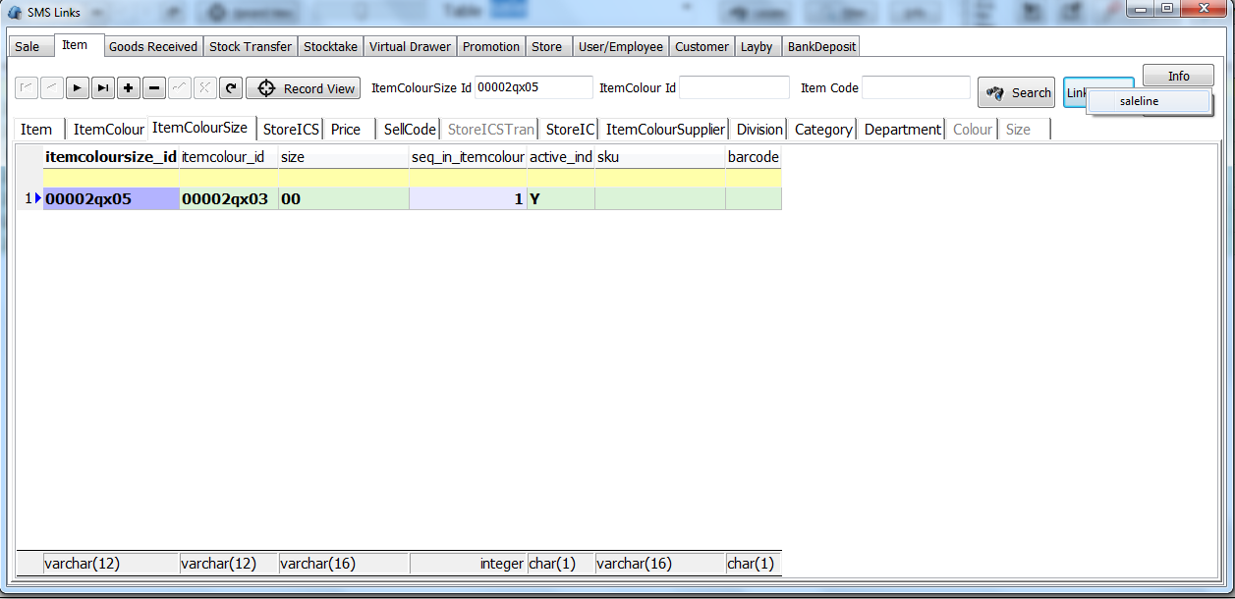

# SMS Tools

These Retail Directions specific tools are particular useful whenever you change database’s or do a PosInstall. Hover your mouse over the different tools to get a hint with more detail. Note, some of these operations are irreversible.

- ‘User Credential Checks’ sets require_key_ind = ‘Y’ or ‘N’ for all activities in the activity table, it cannot remember its original state.

- ‘Reset DataCentre Table’ sets all ip_addresses to 1.1.1.1 and 127.0.0.1 for your register and cannot be reversed.

- Rename Terminate.exe renames the file to _terminate.exe in your C:\POS folder.

- Screen Alignment changes the value of screen_alignment_ind in the register table you’re your register.

-Create User creates a remediuser with full priviledges for all type_ind = 'A' activities, by inserting records into the remediuser, remediuserkey, remedikey, remedikeyaccess, employee, employeestore tables.

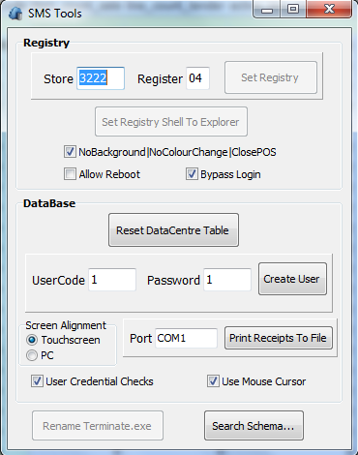

By pressing ‘Search Schema…’, you can search through all the schema .ddl files looking for a particular phrase or simply view the .ddl file of a particular table. If searching for a phrase, ticking ‘SMS Tables Only’ is slightly faster. At this stage, the .dll files are read only.

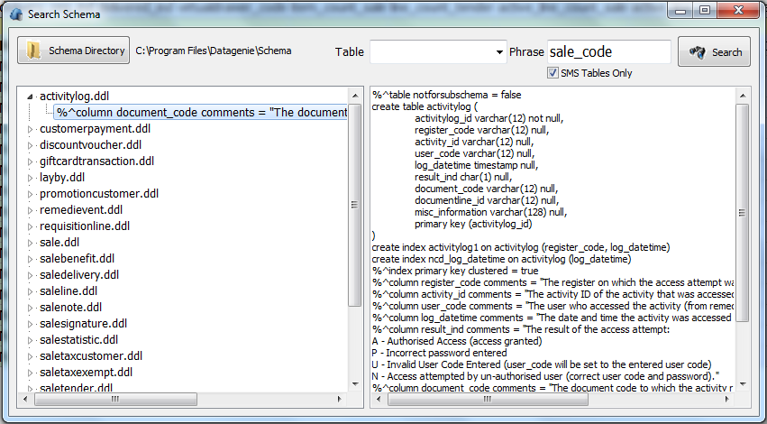

# Settings

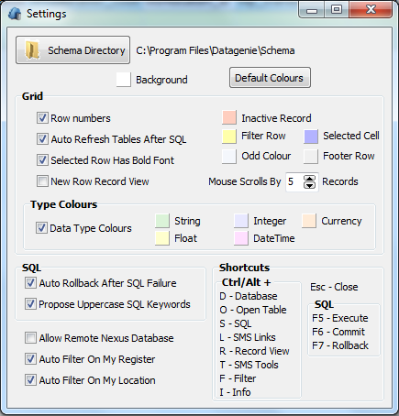

These settings are stored as registry settings under the section RMS/POS/SMSDE/

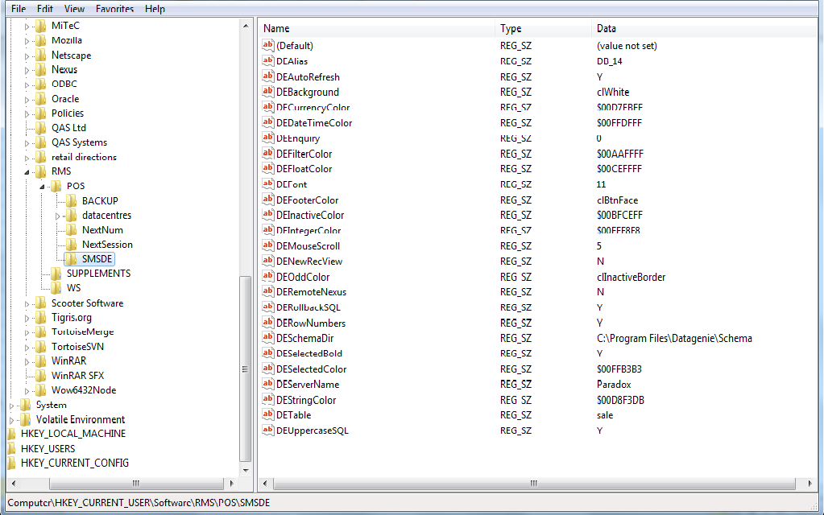

Hopefully most of these settings are self-explanatory.

‘New Row Record View’ – This is equivalent to pressing ‘Record View’ straight after inserting a record.

‘Auto Refresh Tables After SQL’ – If you perform some sql which changes data in the sql editor, it will automatically refresh the tables you have open in the tabs.

‘Auto Rollback After SQL Failure’ – Suppose you were executing 5 SQL statements in one go. The first 2 statements execute successfully but the 3rd one fails. It won’t attempt to execute the 4th and 5th. If you still want the option to commit the first 1st and 2nd statements then turn this setting off.

‘Auto Filter On My Register/Location’ – If you open any table that has ‘register_code’, ‘store_code’ or ‘location_code’, it will automatically filter on your register/store using the filter row.